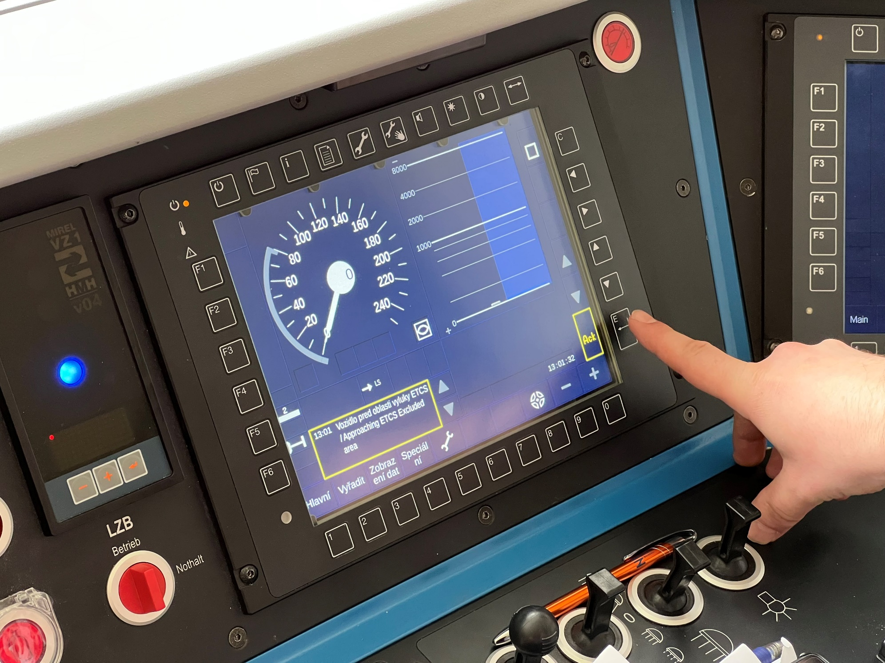

Pardubice ETCS Driving Simulator
Annex 2 – List of Questions
Preliminary Market Consultation

Lukáš Matta
ETCS and Modern Technologies Unit
Directorate General, Signalling and Telecommunications Department

Table of contents
Questions for the preliminary market consultation 3
1.1 Implementation part 3
1.2 Technical part 4
1.3 Operational availability part 6

Questions for the preliminary market consultation

Implementation part
What conditions in the tender documents do you perceive as fundamentally limiting in terms of your company's possible involvement in the contract for the design and installation of the ETCS simulator?
Do you see any other risks in the case of implementing the ETCS simulator technology supplied by you? If yes, please specify them.
According to the documentation provided, what do you consider to be adequate costs for the implementation of the contract?
Do you propose to conclude a subsequent Service Level Agreement (SLA) of the contract for the maintenance and possible upgrade of the ETCS simulator, or should the service be part of the works contract?
What costs do you consider adequate for the maintenance and future development of the work and over what timeframe should such support be provided? Please indicate the estimated cost per year.
Do you find the Contracting Authority's requirement for the Contractor to provide comprehensive design and project documentation for the implementation of the ETCS simulator in Design and Build mode to be reasonable? Do you have specific experience with this?
Do you consider the evaluation criterion of economic advantage based on the lowest tender price to be an appropriate means for the Contracting Authority to ensure the selection of the Contractor? What other evaluation criteria do you recommend?
In your opinion, what should be the technical qualification requirements in relation to the reference contracts to match the complexity and scope of the planned contract?
To what extent do you foresee the involvement of subcontractors? Please specify which part of the performance you would subcontract.
How long do you consider the deadline for submission of tenders to be sufficient?
Would you be interested in having the forthcoming public contract include, in addition to the actual Design and Build, the provision of operational capability (in Design and Build and Operate mode) of the equipment you supply for a period of 10 years?
What would be the approximate percentage of the cost of providing this operability (Operate mode) compared to the contract implementation in Design and Build mode only?
Do you consider it realistic to complete the implementation of the ETCS simulator by 31 December 2023? Can the implementation be completed earlier? If so, how?

Technical part
What modifications to the technical and functional specifications for the ETCS simulator do you recommend compared to the current version and for what reason? Can you describe their advantages and disadvantages?
Would you suggest adding any functions and features to the device beyond those required by the Contracting Authority? If so, which ones and why?
Do you perceive any technical and functional requirements of the Contracting Authority as difficult or as a barrier to implementation? If so, which ones and why?
What display technology are you considering for the ETCS simulator? Display, projection, or other? Please specify which one you think is most appropriate and why.
How do you propose to modify or improve the proposed layout of the vehicle control panel supplied by the Contracting Authority, taking into account the planned selection of two different vehicle types and the use of two different automatic train protections (MIREL VZ1 v4 and KBS06)?
Do you offer your own solution for a generic, approximated control panel that would meet our requirements and possibly be ready for simulation of an electric traction vehicle? If so, can you provide reference projects?
Do you recommend the proposed partial cabin solution to be modified or possibly supplemented with additional technologies (e.g. simulating cabin lighting based on time of day)? If so, what would be the solution?
What technology do you propose for displaying selected indicators (in particular the MIREL VZ1 v4/KBS06 automatic train protections and air gauges) in the cab? Are you able to supply real hardware elements or just a simulation on the display?
Is the simulator technology you are designing capable of creating and editing simulation scenarios and maps, or do you require descriptions of the network and desired scenarios before implementation and will they not be able to be changed?
What technology or process do you suggest for creating test and simulation scenarios for the instructor? Is it required to allow the instructor to intervene in the simulation while it is running – do you offer this option? If not, please tell us why.
Is the simulator technology you are proposing capable of handling predefined onboard unit and trackside faults as required in the technical and functional requirements chapter? If not, please specify why.
What is the expected lifetime of your proposed technology?
What timeframe do you expect for testing the installed equipment in Pardubice?
What specific activities would need to be provided by the Contracting Authority to ensure customer tests?
What is the timeframe for the customer tests required to demonstrate that the Contracting Authority's requirements have been met and the overall functionality of the work?
What is your ability to guarantee the availability and reliability (in percentage) of the entire system delivered?
Has your proposed ETCS simulator been implemented by another railway infrastructure manager or carrier? Can you provide reference projects?
What do you see as possible difficulties and obstacles in implementing national rules and elements in the simulator? Will be regulations, instructions and specifications of the state organisation of Správa železnic, as the Contracting Authority, sufficient for your implementation?
How do you foresee the solution of links to real radio stations?
Is the simulator technology you are designing capable of interfacing with other simulators or other technologies through interfaces? If yes, please specify how and with what.

Operational availability part
Is your company interested in providing maintenance, support and upgrades for the proposed ETCS throughout the lifetime of the system?
What do you consider to be an appropriate and reasonable length of time to support your proposed ETCS simulator technology? What is standard period of time for which the full support of the delivered technology is provided by the Contractor?
In your opinion, is it standard to request an upgrade of the delivered system in terms of behaviour, models, world map or hardware? How do you propose to address the issue of future simulator upgrades based on the requirements of the Contacting Authority? If a future upgrade is not possible, why?
In your opinion, is it standard to require an upgrade of the delivered system in terms of the behaviour of the trackside and onboard unit (modification of national values, transition to newer versions of the ETCS specifications according to the CCS TSI and related Subsets?) How do you propose to address the issue of future simulator upgrades based on the requirements of the Contacting Authority? If a future upgrade is not possible, why?
What are the practices and commonly accepted processes for dealing with the modifications and upgrades described in the previous questions?
How do you propose to define the contractual setting of the issues of the above mentioned changes in the simulator operation (in particular, behaviour according to national values, new installations of trackside, change of specifications) that result in the necessity of modifications of the work, during the development/installation, warranty period and afterwards?
For how long can you guarantee delivery of spare parts? In your opinion, what is the standard guarantee period for the delivery of spare parts?
How do you propose to deal with the contractual treatment of the issue of availability (required functionality) of a facility or part thereof? (definition of requirements, penalties)

Správa železnic, státní organizace
Dlážděná 1003/7
110 00 Prague 1
Czech Republic

© 2023
Version 18/05/2023

